Assignment 8：Site Map, Wireframe and Usability Study

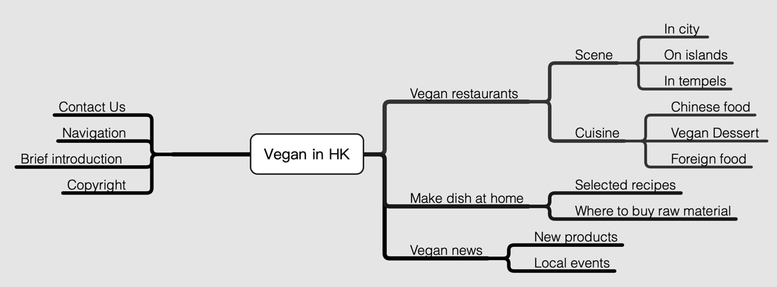**Site Map**

Figure 1 Site Map

With the mission of finding nice and fresh food for vegans in Hong Kong, this website mainly contains 3 functional parts:

1. Vegan restaurants (recommend vegan restaurants by scene and cuisine)

2. Make dish at home (recommend recipes with cooking tutorial videos and find local street markets for users)

3.Vegan news (list vegan new products and local events)

**Wireframe**

Though there’re 2-3 veganism related websites in HK, most of them more focus on

propagandizing the benefits of being vegan and veganism social movement. None of the existing websites indeed designed for finding vegan restaurants and tell people where to buy fresh fruit, vegetables and new vegan products such as omni-pork in HK. Thus, here comes the unique place of my website: After browsing, local vegans and vegan visitors in HK could quickly find vegan products to consume and enjoy.

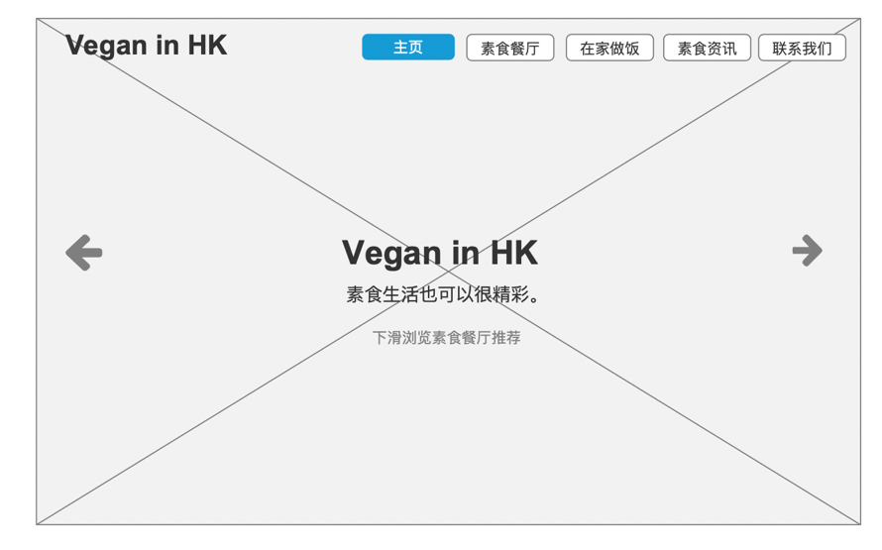

Figure 1.1 Homepage

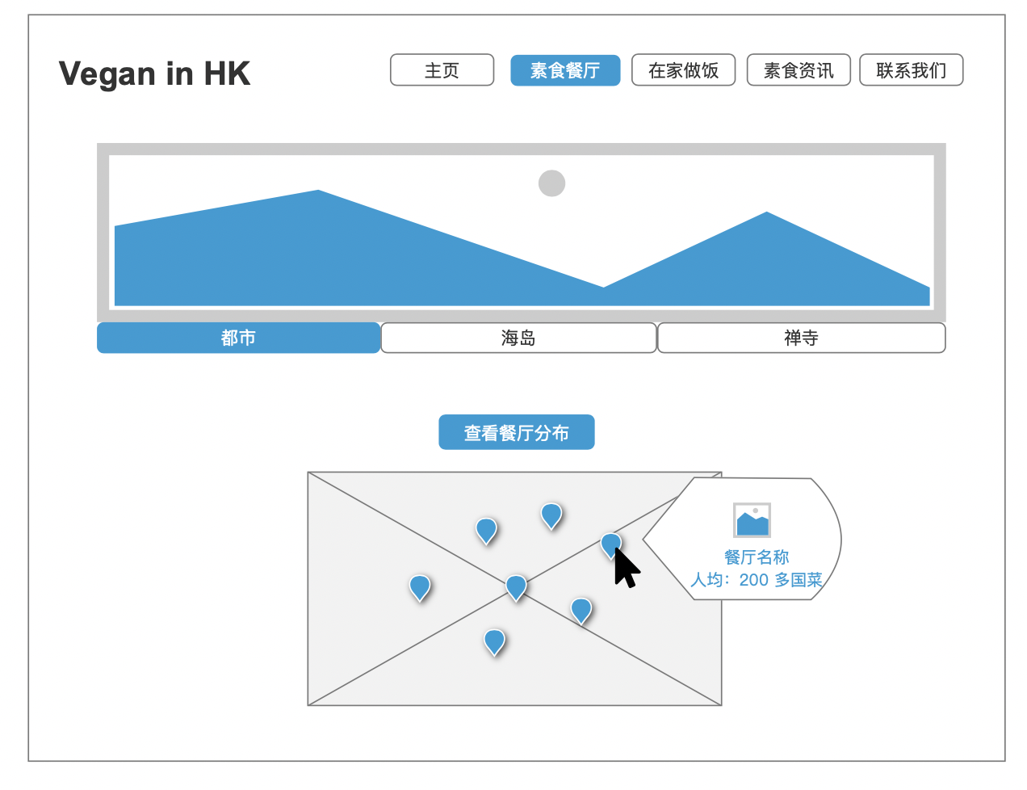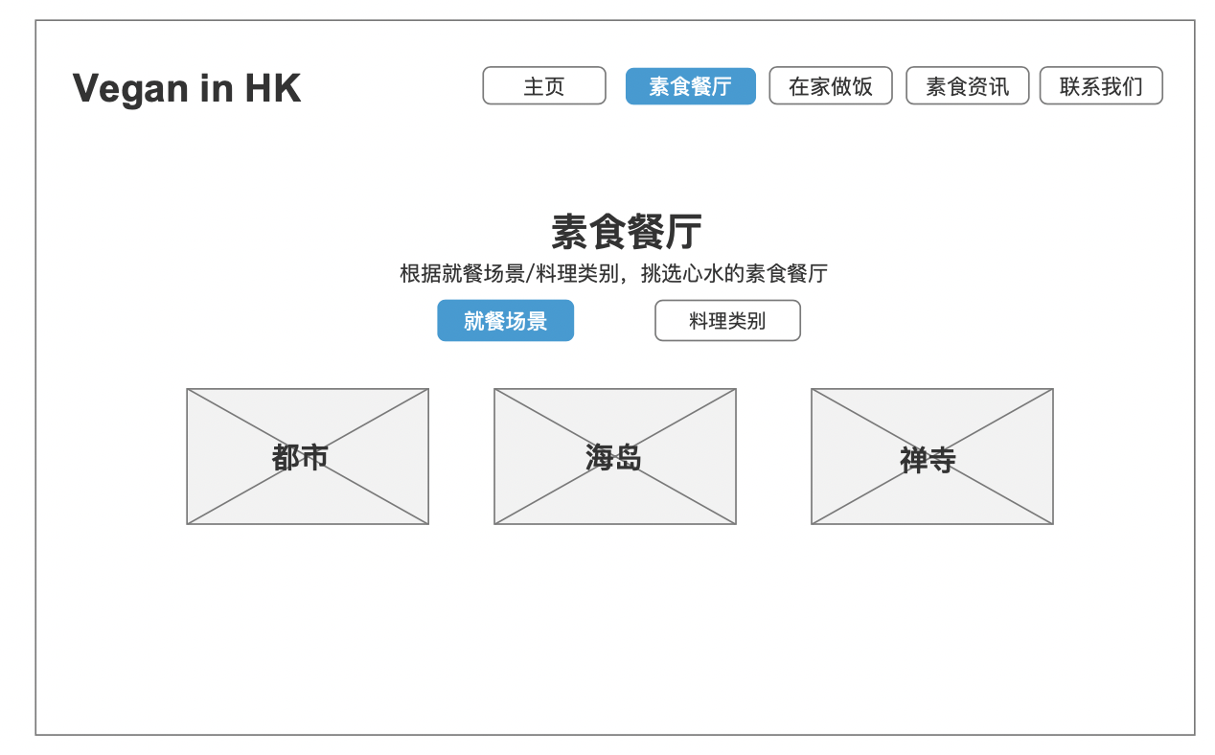

Figure 2.2 Vegan restaurants recommend (By Scene)

Map function

Figure 2.1 Vegan restaurants recommend (By Scene)

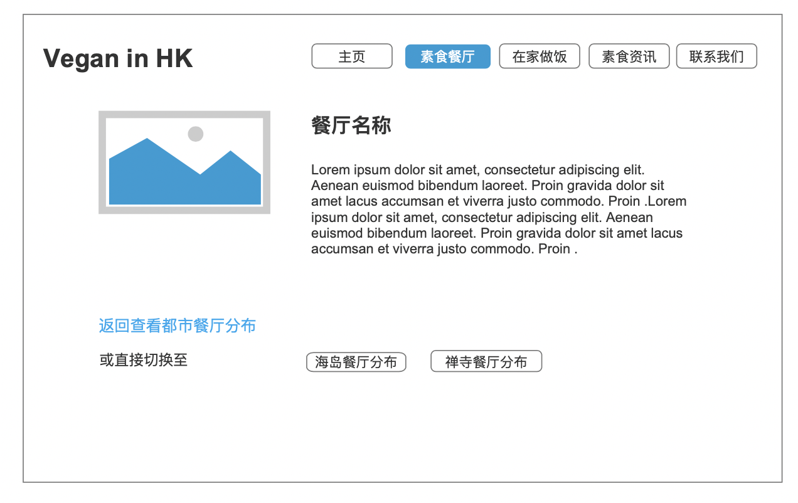

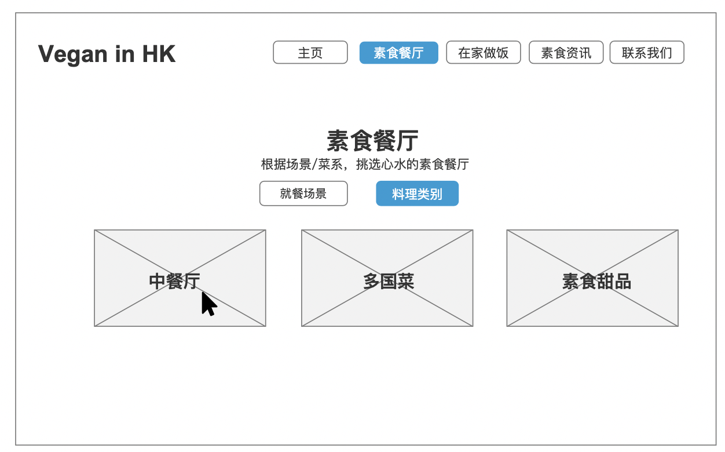

Figure 2.3 Vegan restaurants recommend (By Scene)

Map function-Details

Figure 2.4 Vegan restaurants recommend (By Cuisine)

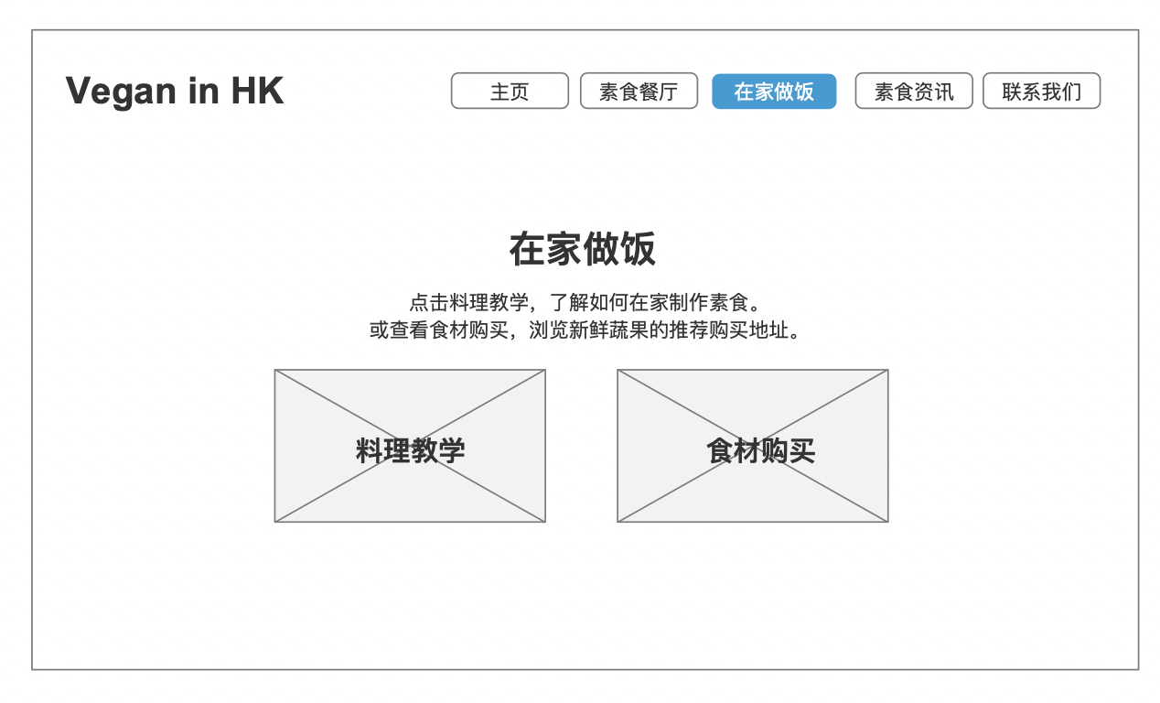 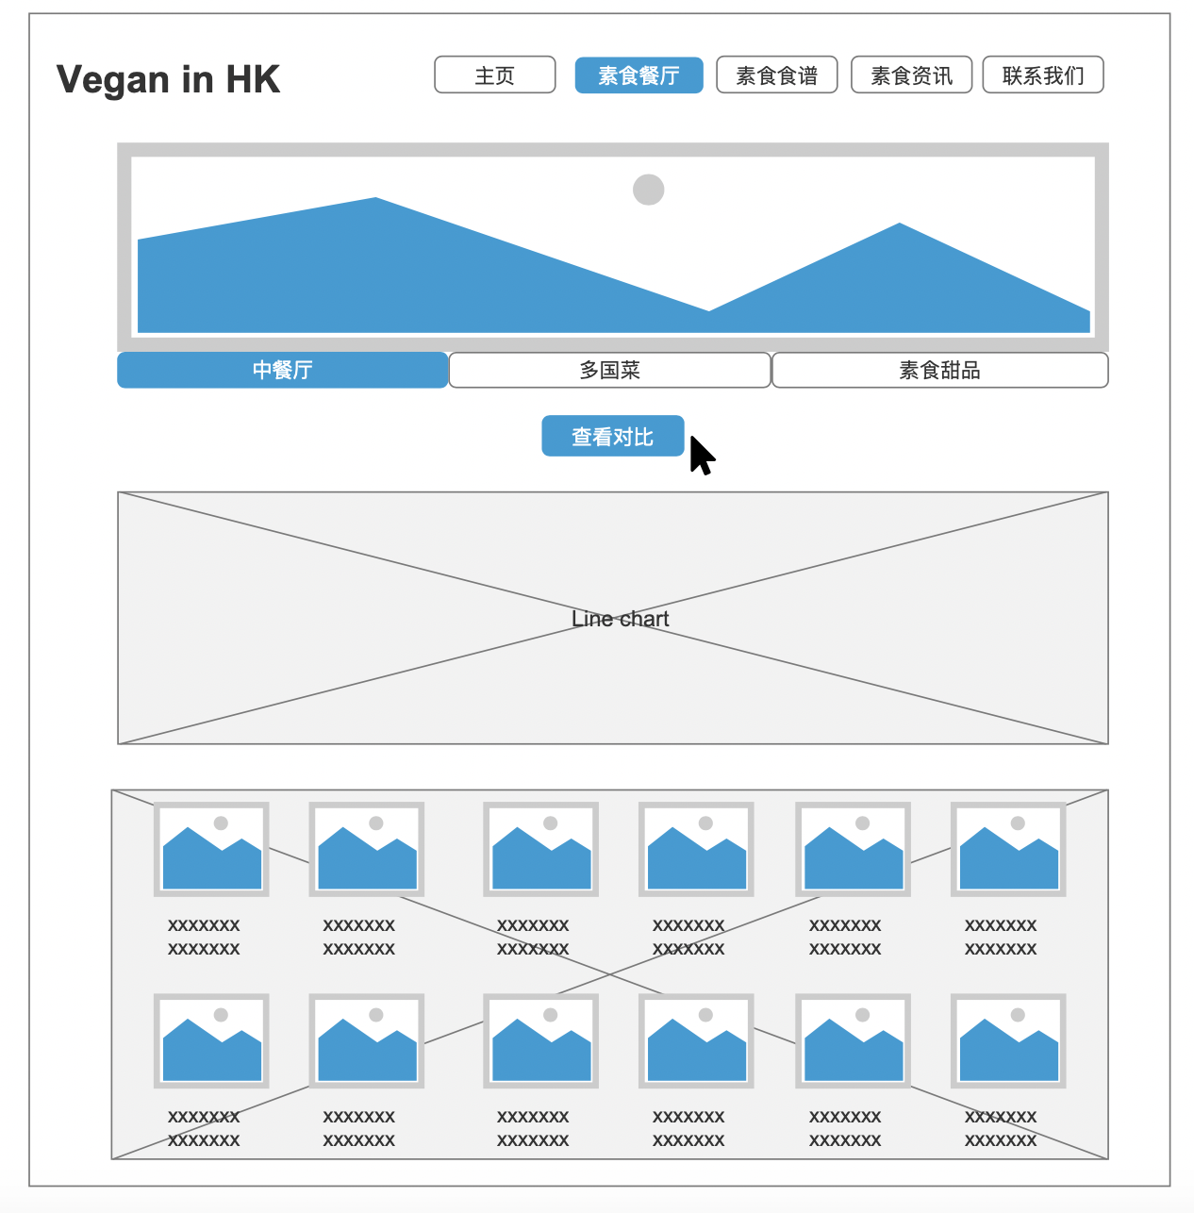

3.1 Make dish at home

2.4 Vegan restaurants recommend (By Cuisine)

Compare function

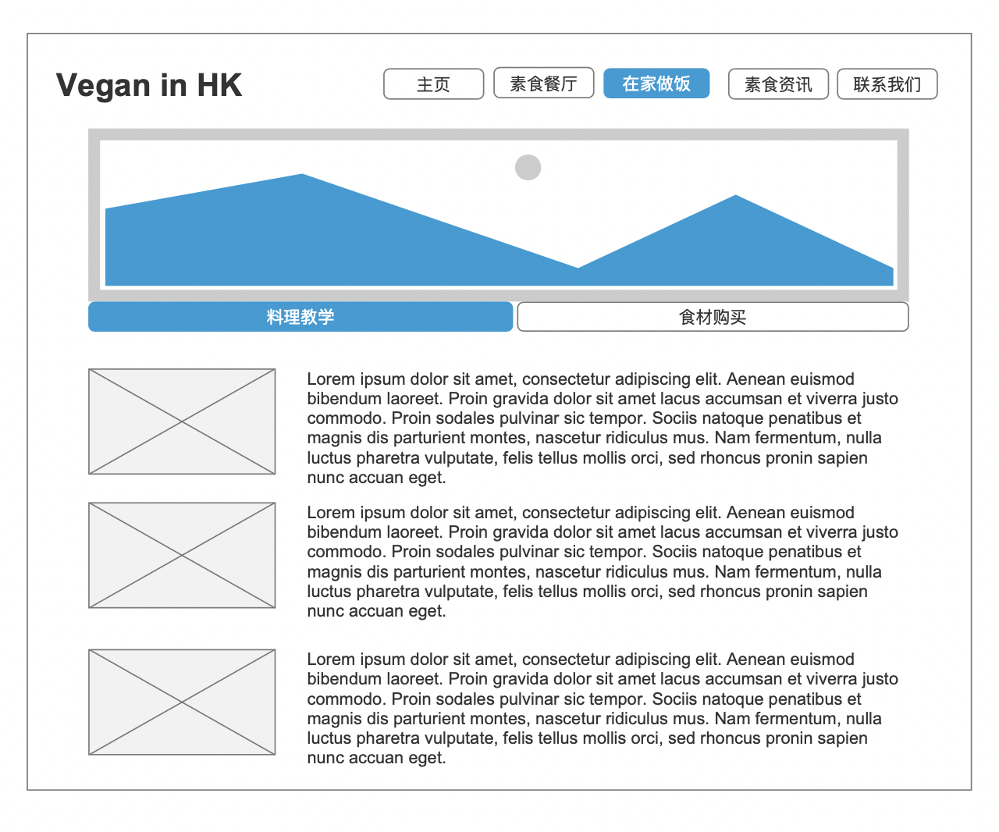

3.2 Vegan dish tutorial

Video and details

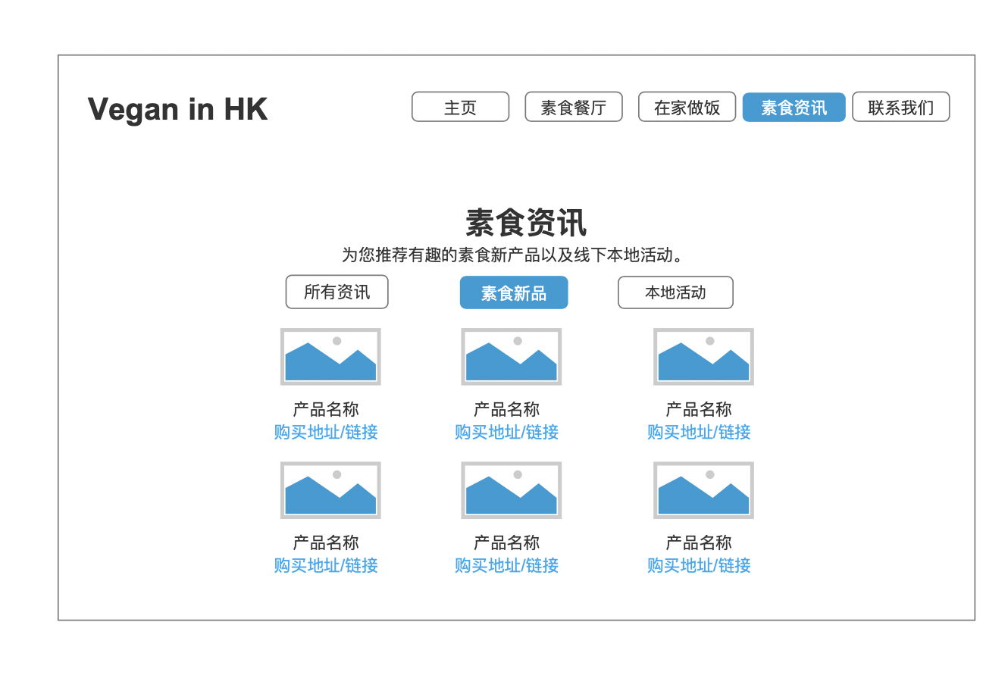

4.1 Vegan news

Filter function

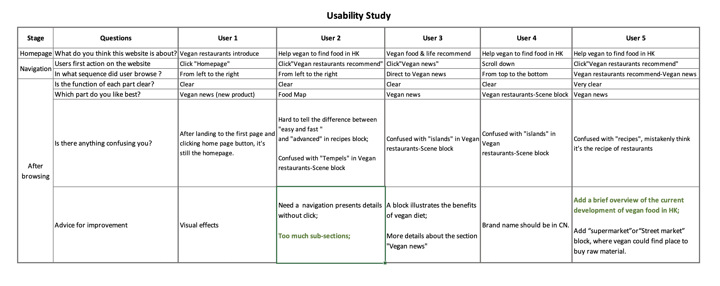**Usability Study**

5.1 Users feedback

In general, five users could understand the aim as well as main functions design of this website. The wireframe attached above has been revised partly according to the usability interview. Confusing messages in the navigation have been amended and details which users want to know more have been added to the vegan news block as well. However, there’re still some quite intelligent advice awaits to be designed in the further improvement such as too much sub-section and a brief overview of the current development of vegans in HK.